User Manual
Project Name: AI-Powered Shop Manager
Version: 1.0
Developed By: Strange Solutions Pvt. Ltd.
Date: 21st Jan 2025

Table of Contents
- Introduction
- System Requirements
- Installation Instructions
- Getting Started
  - Launching the Application
  - Logging In
- Features and Usage
  - Manage Products
  - Manage Sales
  - Sales Analysis
  - Sales Prediction
  - Manage Customers
  - Product Menu
- Security Features
- Troubleshooting
- FAQs
- Support and Contact Information

1. Introduction
This user manual provides detailed instructions on how to use the AI-Powered Shop Manager, a Python-based application designed to automate and simplify shop operations with advanced features like sales analysis and prediction.

2. System Requirements
- Operating System: Windows 10
- Python Version: 3.13
- Required Libraries: tkinter, customtkinter, sklearn, MySQL connector, cryptography, pandas, NumPy,
- Hardware: Not Yet Confirmed

3. Installation Instructions
- Not Yet Confirmed.
- Install Python 3.13 and required libraries using:
- Set up the MySQL database using the provided SQL file
- Run the main application file:

4. Getting Started

4.1 Launching the Application
- Run the command:
python main.py

4.2 Logging In
- Enter your credentials to log into the system.
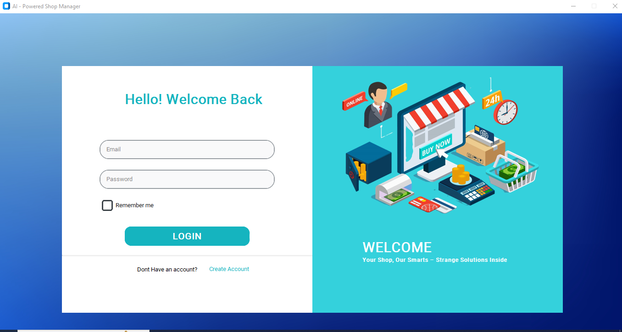
- Register Your Account If You do not Have a one.
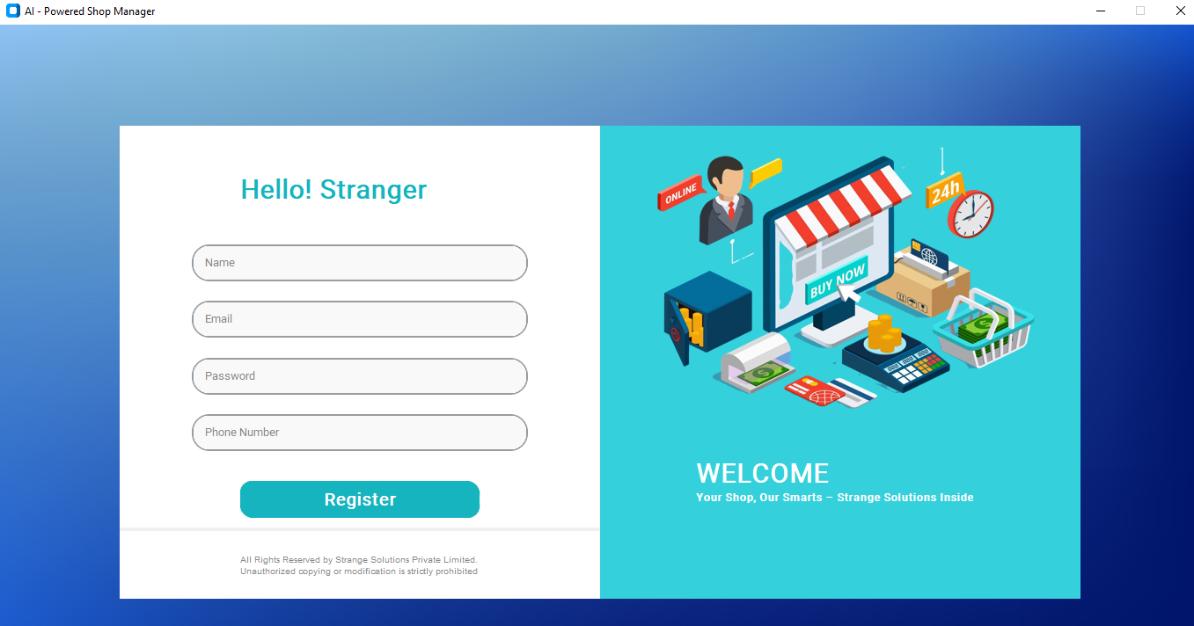

5. Features and Usage

5.1 Manage Products
- Add Product: Navigate to "Manage Products" > Click "Add Product" > Enter product details > Ok.
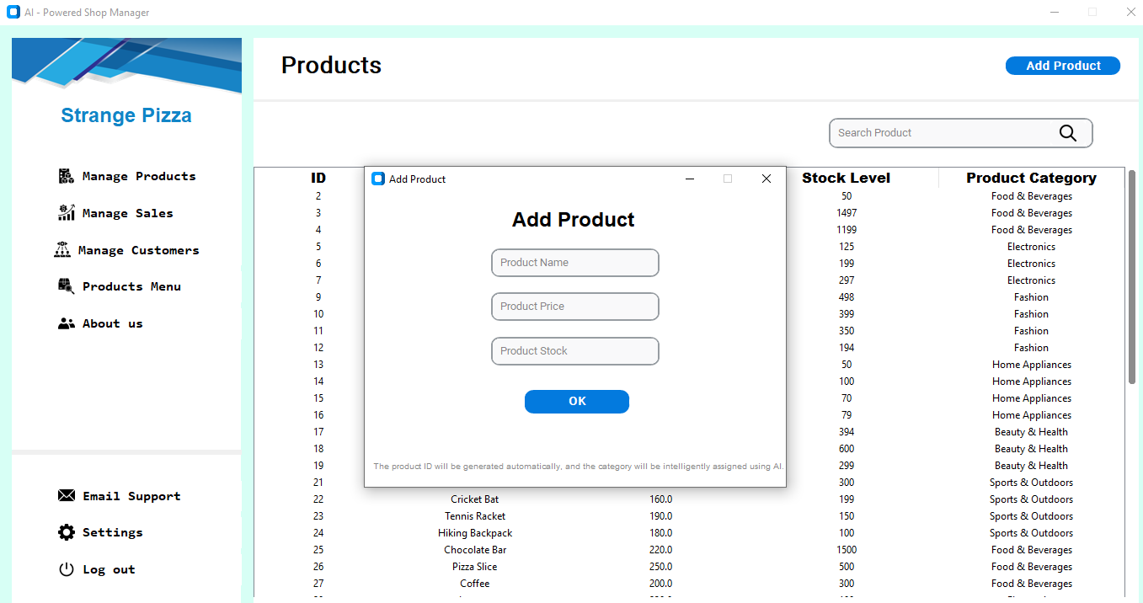
- View Product: Navigate to "Manage Products" > View Products.
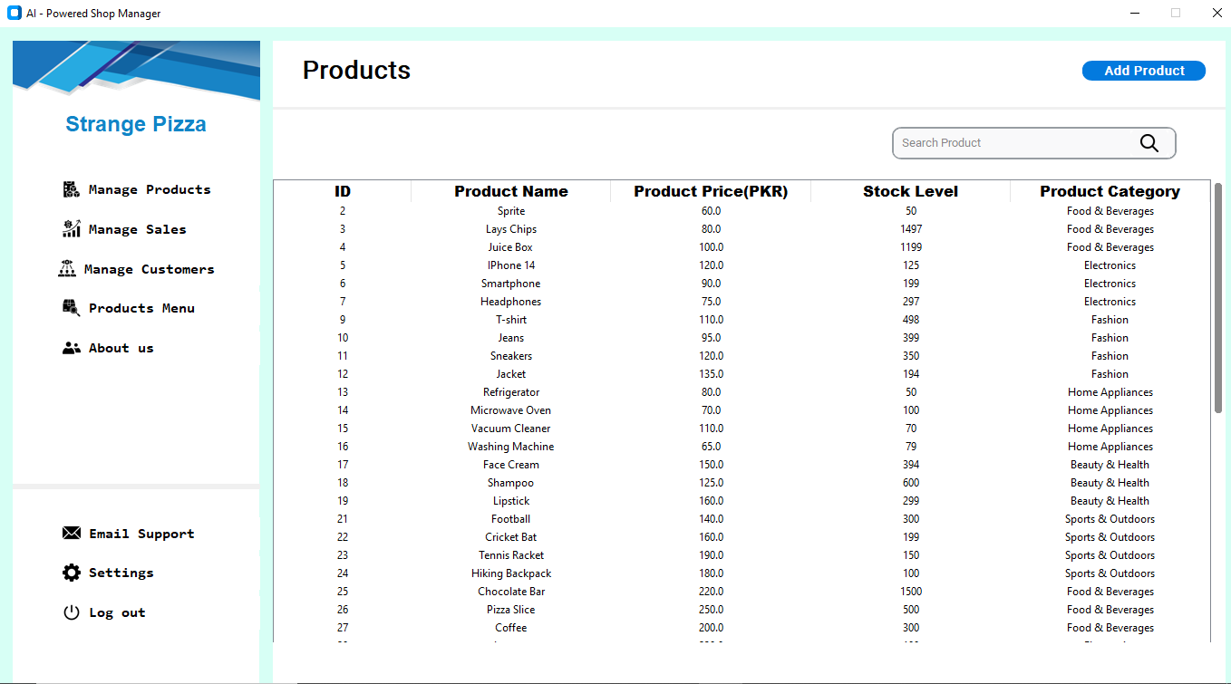
- Search Product: Use the search bar to find products by ID.
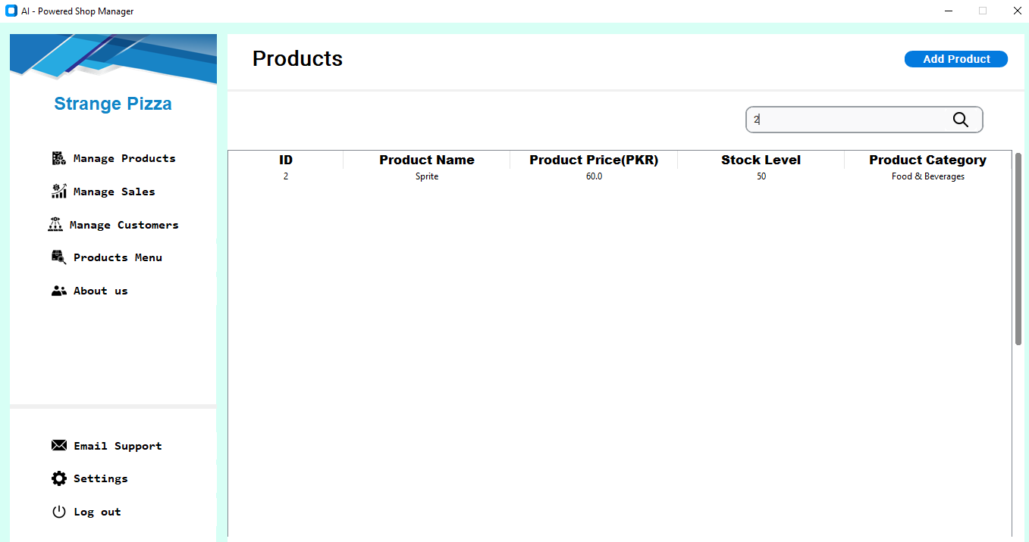

- Alter or Delete Product: Click on the Product You Want to Alter > Right Click On Any Product > “Click Alter or Delete as Your Desired Operation”
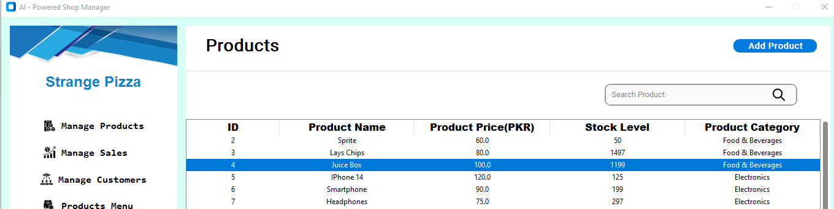

5.2 Manage Sales
- View Orders: Navigate to "Manage Sales" > "View Orders and Orders Details" >> to see a list of all Details.
- Search Orders: Use the search bar to find specific orders or order details by ID..

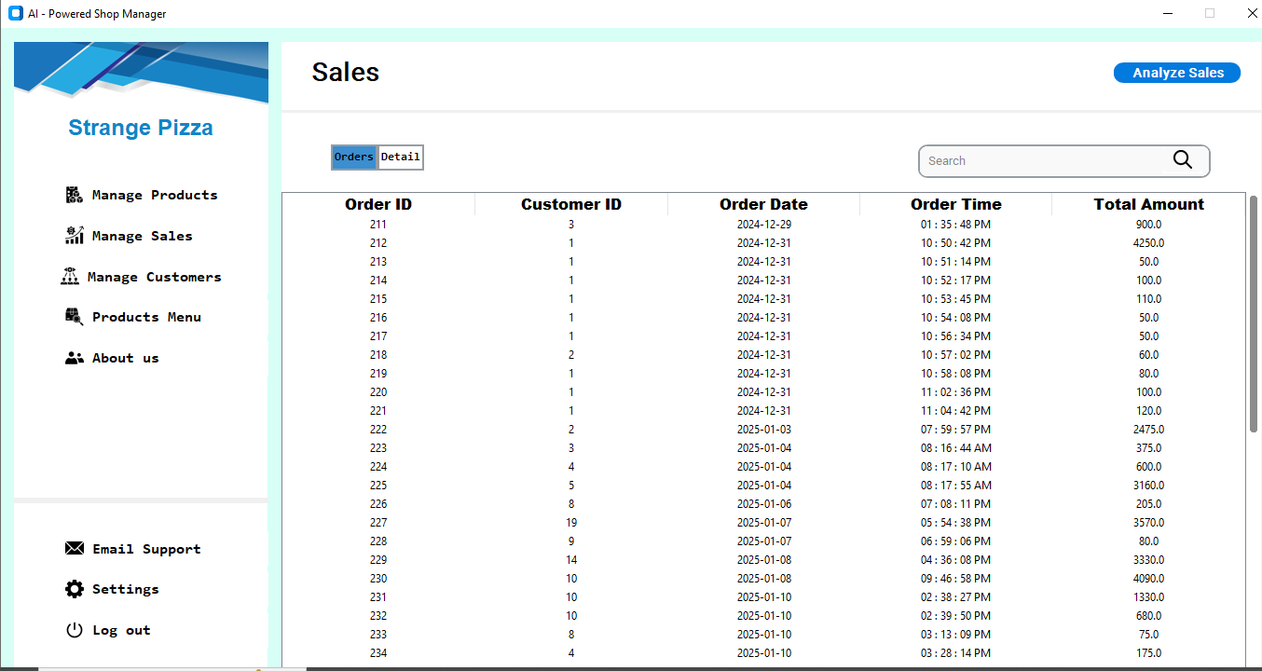

5.3 Sales Analysis
- Navigate to "Analyze Sales" > Select a time frame (daily, weekly, monthly, or all-time) > View graphical trends.
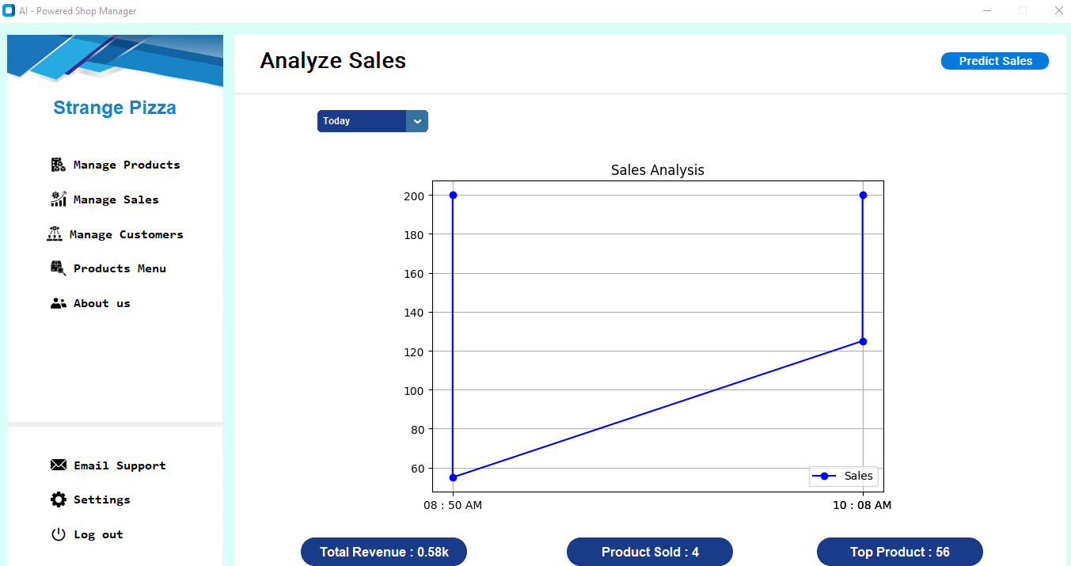

5.4 Sales Prediction
- Navigate to "Predict Sales" > > Select a time frame (weekly, monthly) > View predicted sales in a graph generated by the ML model.
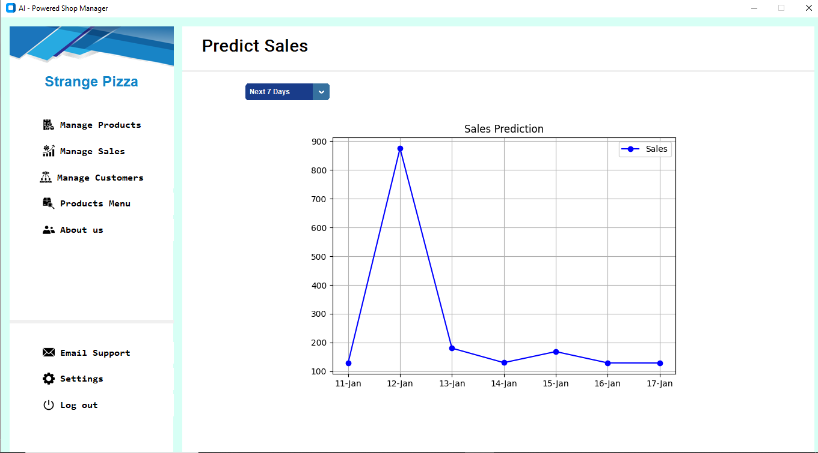

5.5 Manage Customers
- Add Customer: Navigate to "Manage Customers" > Click "Add Customer" > Enter details > Save.
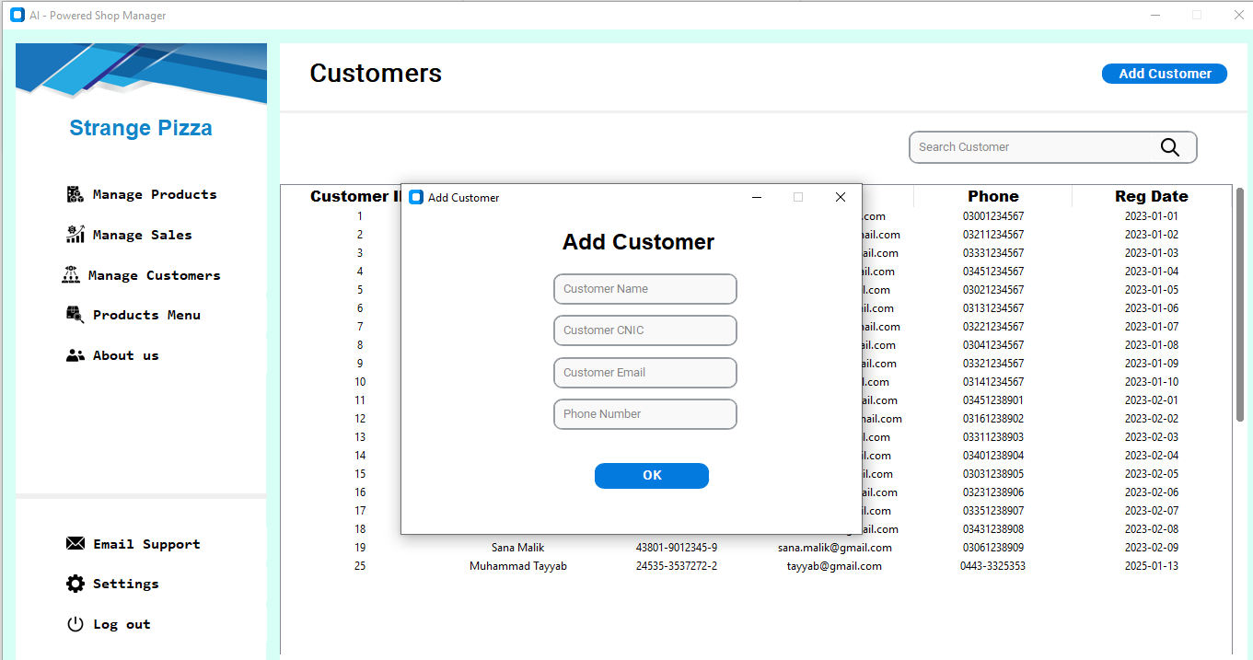
- Search Customer: Use the search bar to find customers by ID or name.

5.6 Product Menu
- Add to Cart: Search for a product by ID or suggestions > Add it to the cart for checkout.
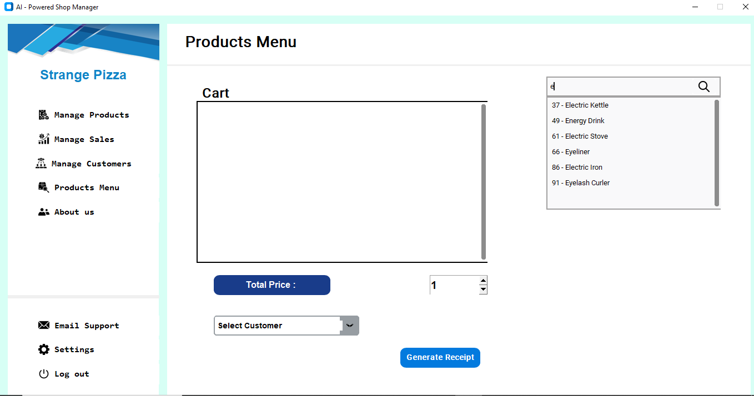
- Add To Cart: Add it to the cart for checkout.
- Update Quantity: Update the Quantity Using the Scroller > Select The Row >> Enter Desired Quantity
- Select Customer: Select the ID of Registered Customer and then generate receipt
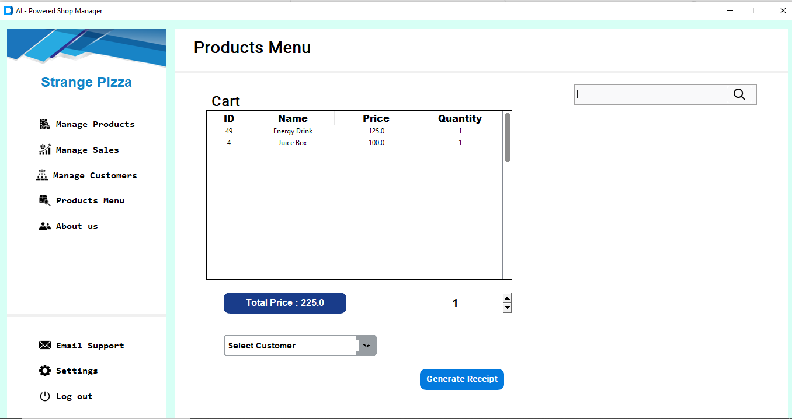

5.7 Settings Page

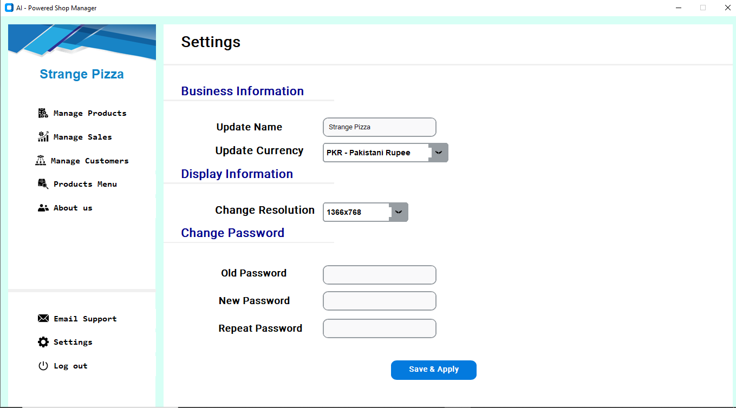

6. Security Features
- Sensitive customer data are encrypted before being stored in the database.
- User authentication is required for access.

7. Troubleshooting
- Issue: Application fails to connect to the database.
  - Solution: Check the database credentials in the configuration file and ensure the database server is running.
- Issue: Graphs are not displaying.
  - Solution: Ensure required libraries like matplotlib are installed.

8. FAQs
- Can I install the application on multiple systems?
Yes, as long as the database server is accessible.
- How do I reset my password?
Go to Settings Page

9. Support and Contact Information
For assistance, contact:
- Email: [zeeshanchudri1234@gmail.com]

